IOT BASED BIRD REPELLENT SYSTEM

SENSING LAYER

System Overview:
The crop prediction system uses a machine learning model to estimate the best crop for a specific region. Users provide input such as soil type, rainfall, temperature, and fertilizer level. The system processes this data and predicts the most suitable crop.

The backend collects and cleans the data, trains the ML model, and performs prediction using algorithms like Random Forest or Decision Tree. It analyzes patterns from historical agricultural datasets to improve accuracy. The model continuously learns and updates.

The frontend GUI allows farmers to enter parameters and instantly view predicted crop results. The system helps increase productivity and reduce financial risk. It supports smarter farming decisions through data-driven predictions.

Tools Used:
Microcontroller: ESP32(with Wi-Fi connectivity)
Sensors Used: PIR sensor
Power supply unit: 5V regulated power for sensors

Techniques:

- Infrared Motion Sensing
- Heat Signature Detection
- Analog–Digital Conversion
- Real-Time Event Detection

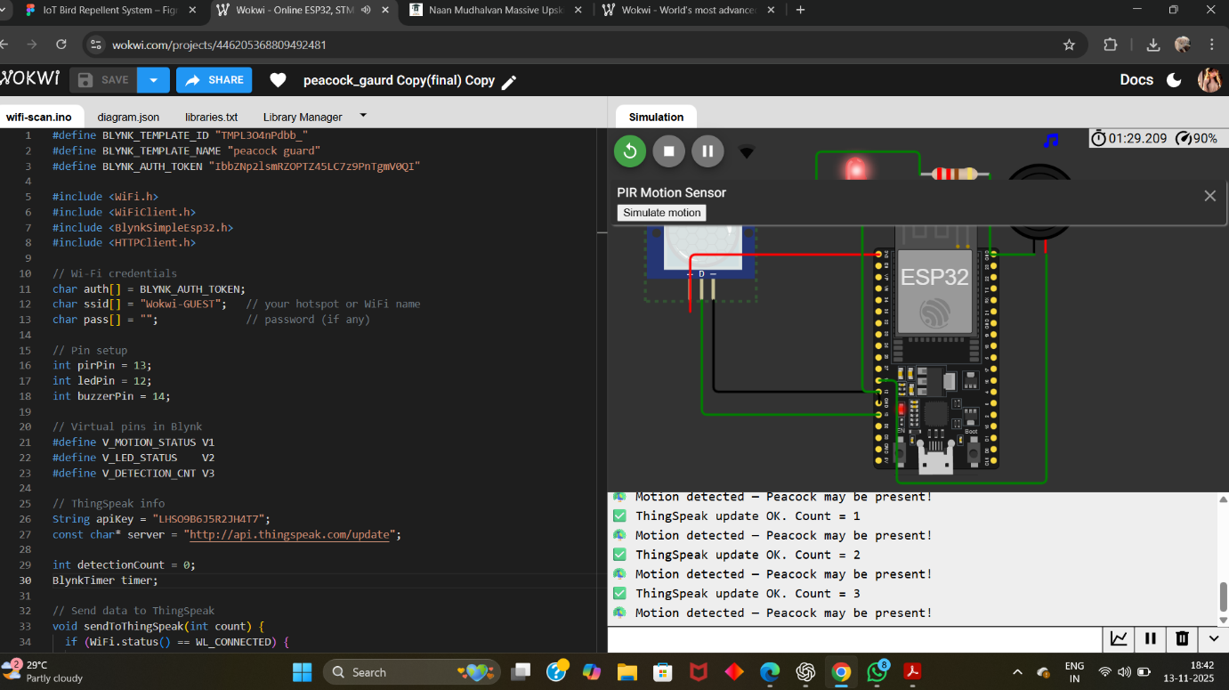
PROCESSING LAYER

The microcontroller (ESP32) receives the input signals from the PIR sensor whenever bird movement is detected in the field. It continuously monitors the sensor data and identifies real-time activity. Once movement is detected, the controller immediately triggers the output device such as a speaker or buzzer to scare away the birds. The sound system is activated automatically without any manual control. The controller can also vary the sound pattern to prevent birds from adapting.
The microcontroller connects to the IoT cloud through Wi-Fi or GSM and sends live field status. If required, a notification message is sent to the farmer’s mobile application. The processing layer ensures continuous monitoring and quick reaction. It logs data for analysis and performance tracking. This layer controls the full automation and decision-making of the system.

Tools Used :

Processor: ESP32 microcontroller
Actuator: Relay Module
Alert: Speaker or Buzzer
Communication: Wi-Fi
Techniques:
Analog-to-digital data conversion
Real-time signal processing
Secure Communication Processing
IoT communication using Wi-Fi

Serial Monitor:
- Displays real-time messages sent by the ESP32.
- Shows “Motion detected – Peacock may be present” when PIR sensor senses movement.
- Shows “No motion detected” when the area is clear.
- Helps verify that the PIR sensor is correctly detecting birds.

CLOUD STORAGE

The cloud storage of the bird repellent system is responsible for storing and processing all detection data from the PIR sensors. When the microcontroller detects bird movement, it sends the information to the cloud using Wi-Fi , ensuring the data is safely saved.
Cloud platforms like Blynk, ThingSpeak display this data in real time through logs and charts. Farmers can view the information on their phones and monitor bird activity from anywhere, making the system reliable and easy to access.
After storing the data, the cloud sends instant notifications or SMS alerts to the farmer whenever birds are detected. This helps the farmer respond quickly and improves the overall efficiency of the bird repellent system.

Tools Used:
Cloud platform: Thingspeak and Blynk
Communication Protocol: HTTP(Thingspeak) and MQTT(Blynk)

Techniques:
- Cloud-based monitoring and real-time alert triggering
- Automated control activation using microcontroller logic
- Data visualization and remote access through mobile or web dashboards

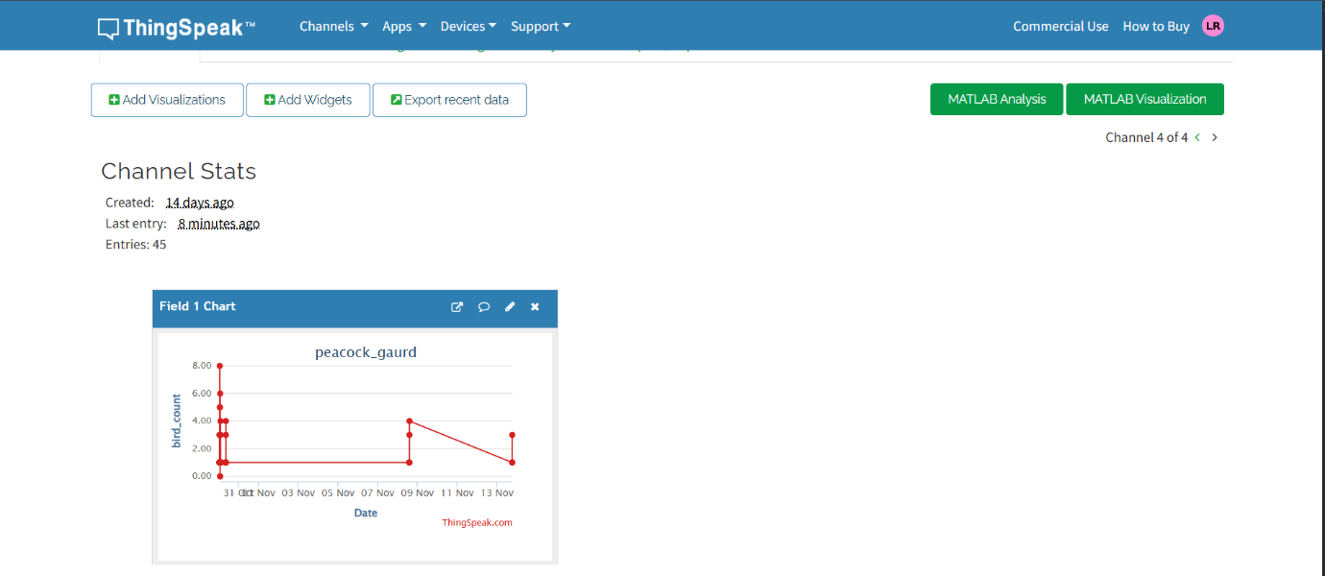

- The chart displays bird detection data of IoT bird repellent system.
- Each data point shows the number of birds detected on specific dates.
- Data is uploaded to ThingSpeak by the ESP32 microcontroller via Wi-Fi
- The graph is labeled “peacock_guard” and tracks bird activity over time.
- This visualization helps farmers monitor bird presence remotely and in real time.
APPLICATION LAYER

Overview:
The Application Layer provides real-time monitoring and control for the farmer. It includes mobile apps or web dashboards that display bird detection alerts, activity logs, and visual graphs. Farmers receive instant notifications via push messages
This layer also lets farmers remotely adjust system settings like sensor sensitivity and speaker activation. It ensures easy and efficient operation of the bird repellent system to protect crops effectively. Additionally, the application layer allows analysis of historical data to identify patterns in bird activity. It can generate reports for better decision-making and optimize the placement of sensors and speakers. Overall, it connects the farmer directly to the IoT system, enabling smarter and safer crop management.

Tools Used:
Devices: ESP32, PIR Sensor, Buzzer/Speakers
Platforms: IoT Cloud(Thingspeak/Blynk)

Techniques:
- Virtual Pins: Display sensor readings and system status.
- Event Alerts: Instant notifications sent to the farmer when birds are detected.
- Mobile Dashboard: Shows detection count, relay status, and control widgets.
- Wi-Fi Cloud Integration: Enables remote monitoring and alerting through the internet.

Visual Output:
- Bird detection status is shown using LED widgets (Green = No Birds, Red = Bird Detected).
- Relay status for horn/buzzer is displayed through a button widget (ON/OFF).
- Detection count, sensor readings, and system activity appear on the dashboard.
- Instant notifications are sent automatically when bird movement is detected.

Blynk Dashboard:

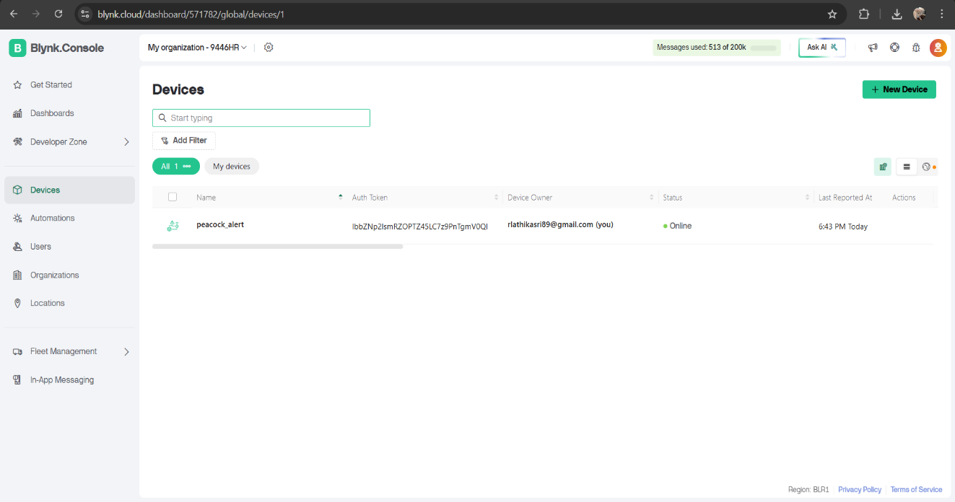

- The dashboard shows device peacock-alert connected to Blynk Cloud.
- The green online indicator confirms the device is active.
- It displays the device owner and connection details.
- From this screen, we can open the device to view sensor data and controls.
- The left menu gives access to Dashboards, Automations, and Notifications.

Mail Notification:
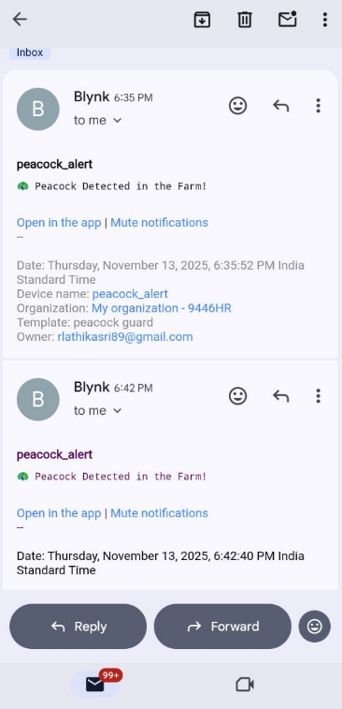

FIGMA DESIGN

Design Components :
- Sensing: Detects bird presence using PIR motion sensors and optional ultrasonic sensors for enhanced accuracy.
- Processing: ESP32 processes sensor inputs, verifies bird activity, and triggers repellent actions.
- Cloud Storage: Bird detection events are stored in Blynk/ThingSpeak for real-time monitoring and data visualization.
- Application: A mobile app interface provides instant alerts, system status, and remote monitoring for the farmer.

Workflow in Figma :
- Design: Developed UI screens representing each stage of the system—Sensing, Processing, Cloud, and Application—showing how the components interact.
- Prototyping: Linked screens with interactive buttons and overlays to demonstrate detection flow, alert generation, and cloud updates.
- Testing: Used Presentation mode to test navigation, transitions, and user interactions to ensure a clear and intuitive system workflow.

Purpose of the Design :

The Figma prototype illustrates how the IoT Bird Repellent System detects bird activity, activates sound repellents, updates cloud data, and notifies the farmer automatically. It helps visualize the complete user experience, from field detection to mobile alerts, in a clean and user-friendly interface.

PROTOTYPE

Work Flow:

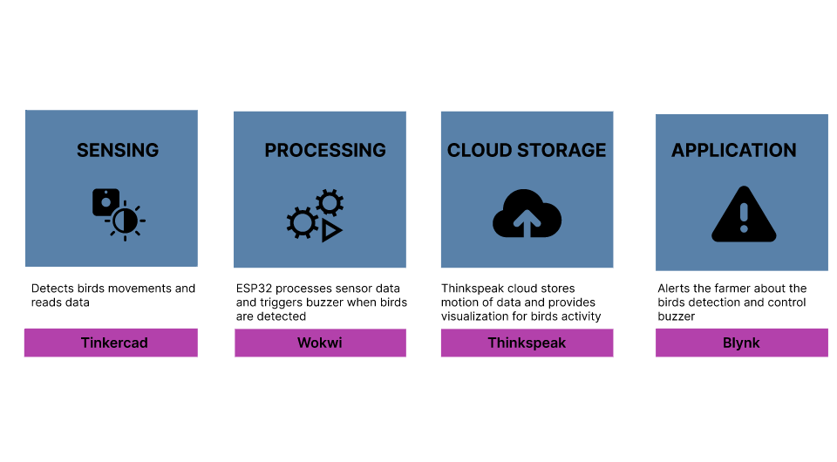
Sensing:
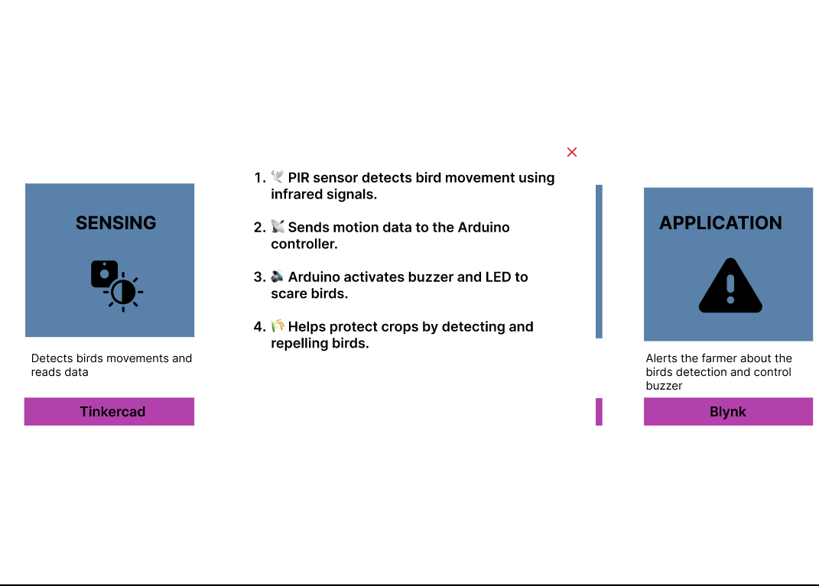

Processing:
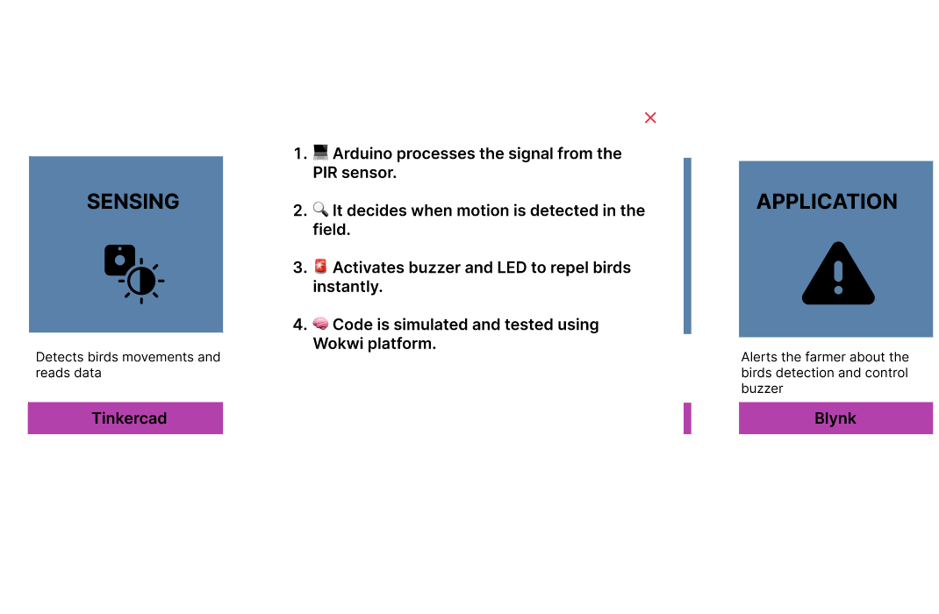

Cloud Storage:
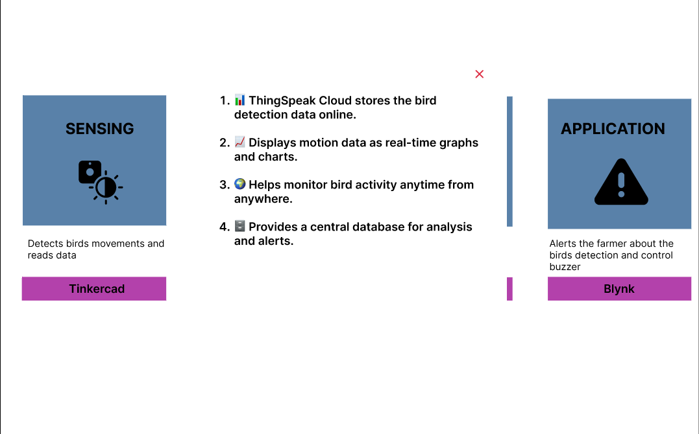

Application:
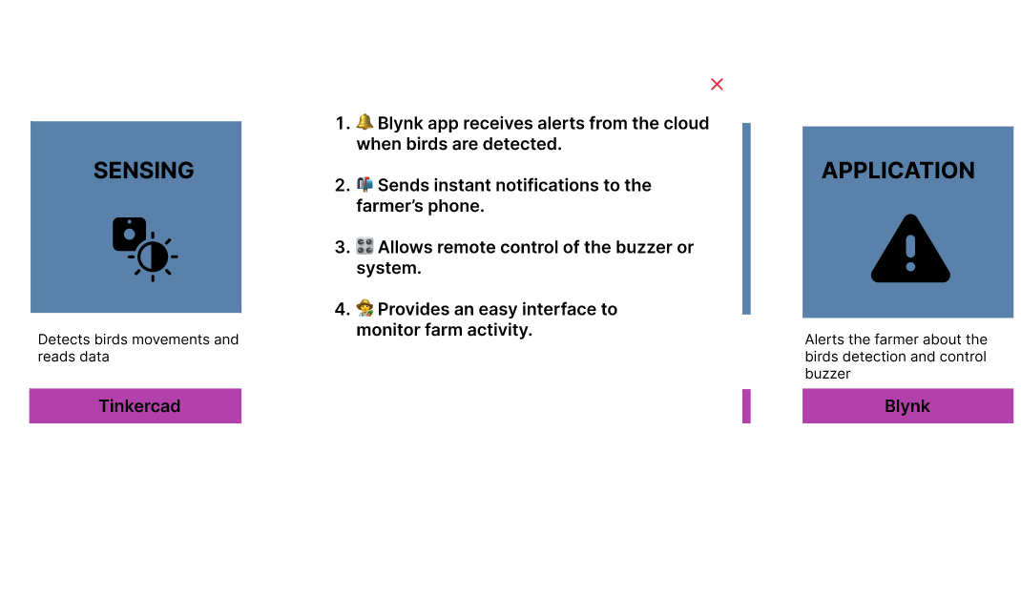
DASHBOARD:
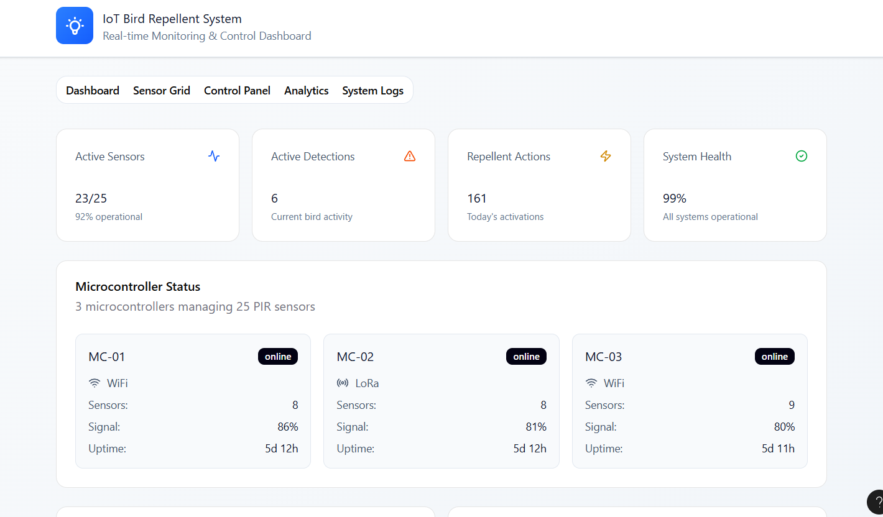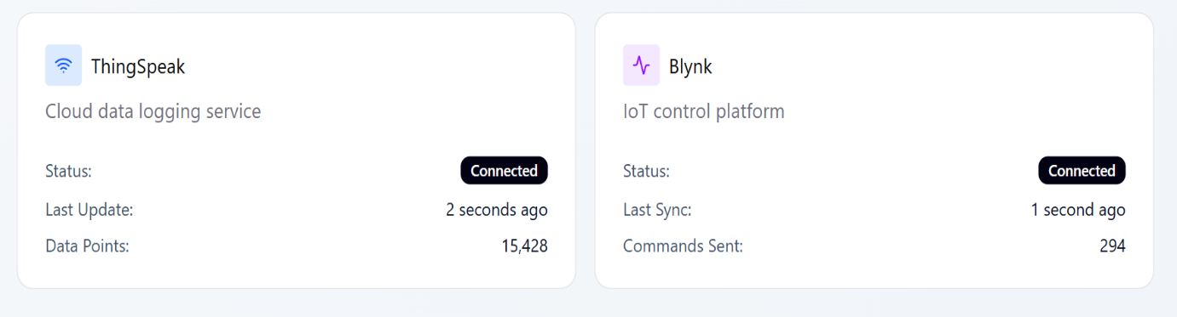

SENSOR GRID:

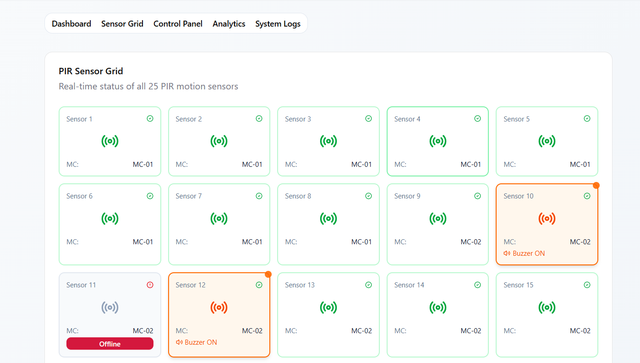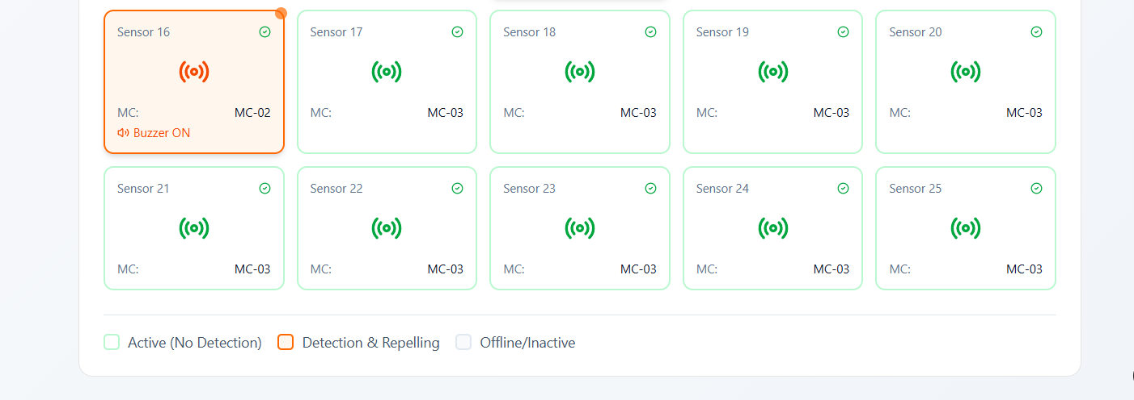

CONTROL PANNEL:

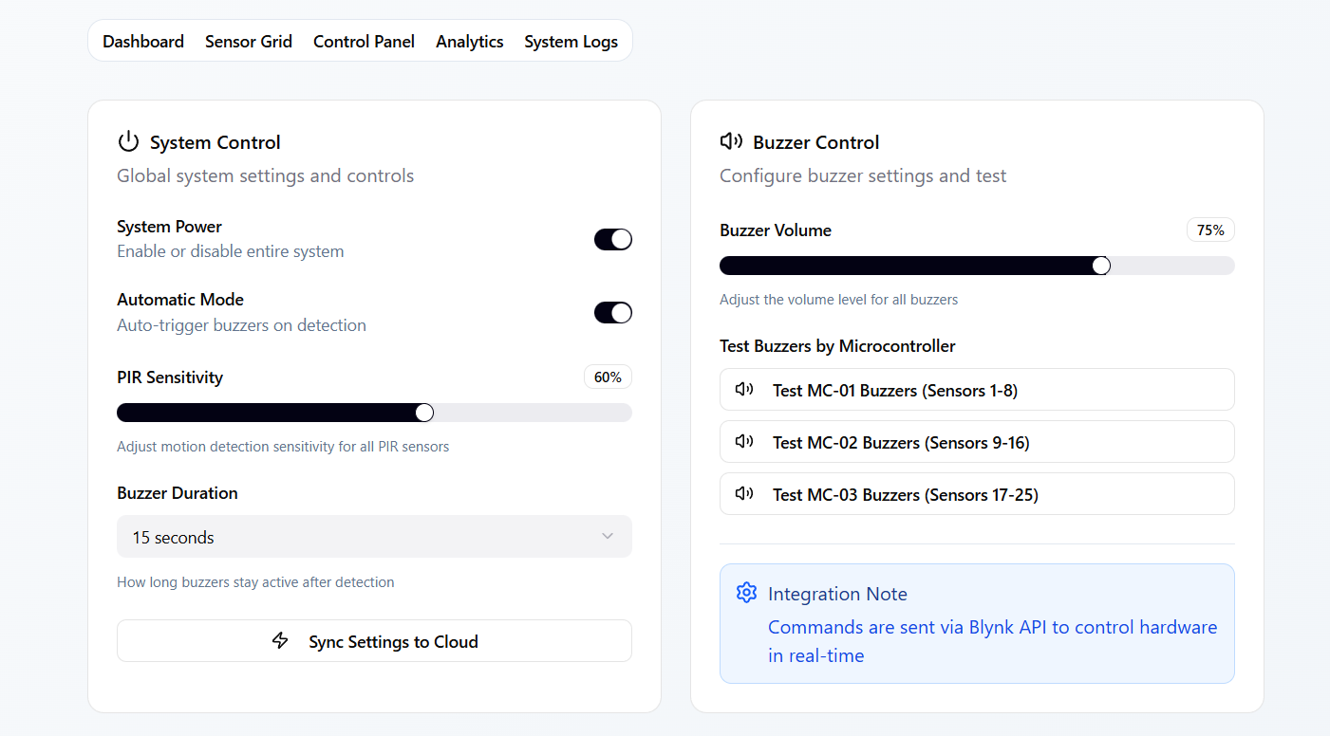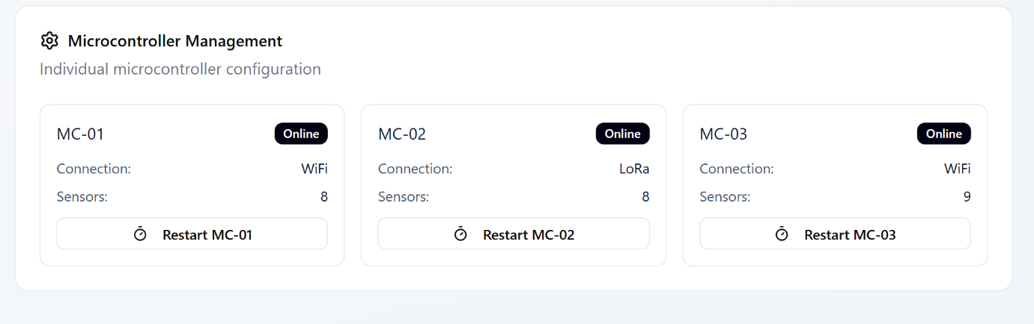

ANALYTICS:
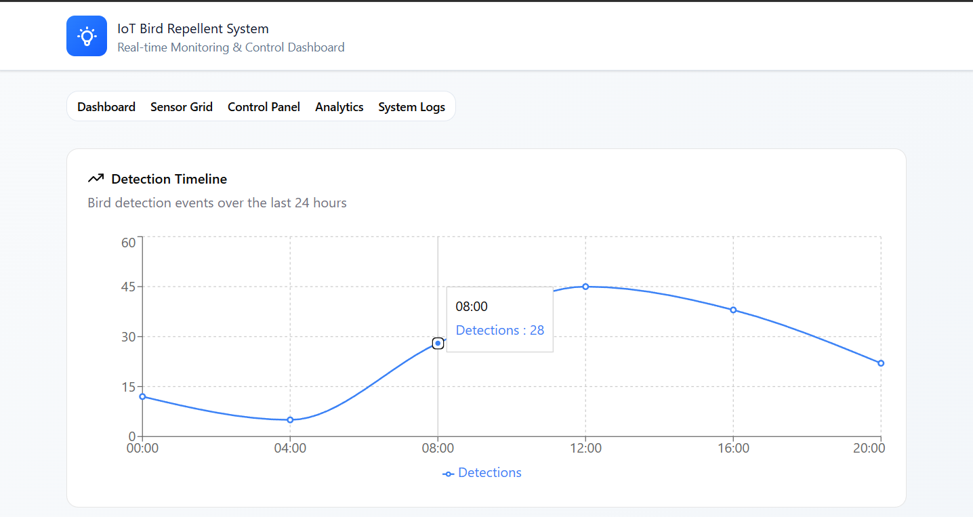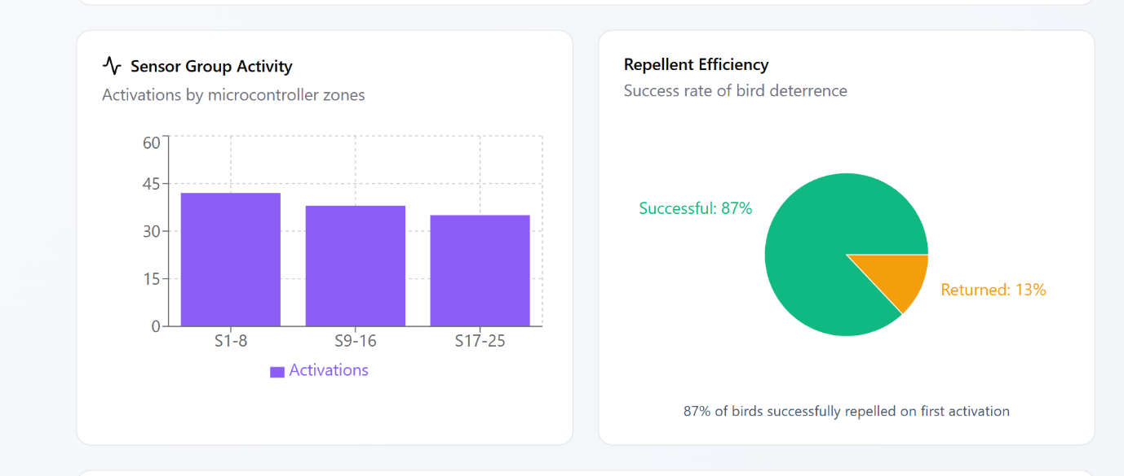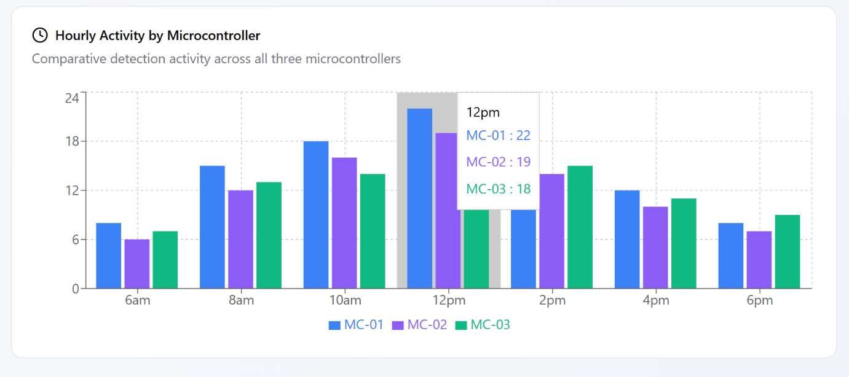
SYSTEM LOGS:

